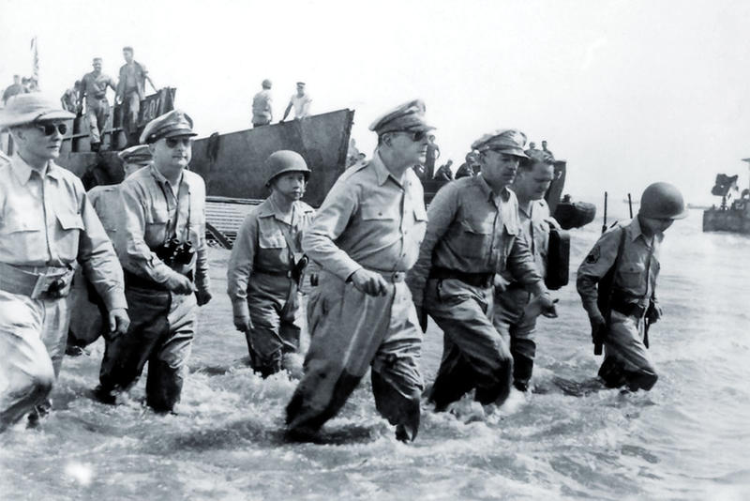
Name ______________________________________ Date ___________

“I Shall Return”

After struggling against great odds to save the Philippines (locate on Map of Pacific) from Japanese conquest, U.S. General Douglas MacArthur abandons the island fortress of Corregidor under orders from President Franklin Roosevelt (March 1942.) Left behind at Corregidor and on the Bataan Peninsula were 90,000 American and Filipino troops, who, lacking food, supplies, and support, would soon fall to the Japanese offensive.
After leaving Corregidor, MacArthur and his family traveled by boat 560 miles to the Philippine island of Mindanao, braving mines, rough seas, and the Japanese Navy. At the end of the hair-raising 35-hour journey, MacArthur told the boat commander, John D. Bulkeley, “You’ve taken me out of the jaws of death, and I won’t forget it.” On March 17, the general and his family boarded a B-17 Flying Fortress to Northern Australia. During this journey, he was informed that there were far fewer Allied troops in Australia than he had hoped. Relief of his forces trapped in the Philippines would not be happening anytime soon. Deeply disappointed, he issued a statement to the press in which he promised his men and the people of the Philippines, “I shall return.” The promise would become his mantra during the next two and a half years, and he would repeat it often in public appearances.
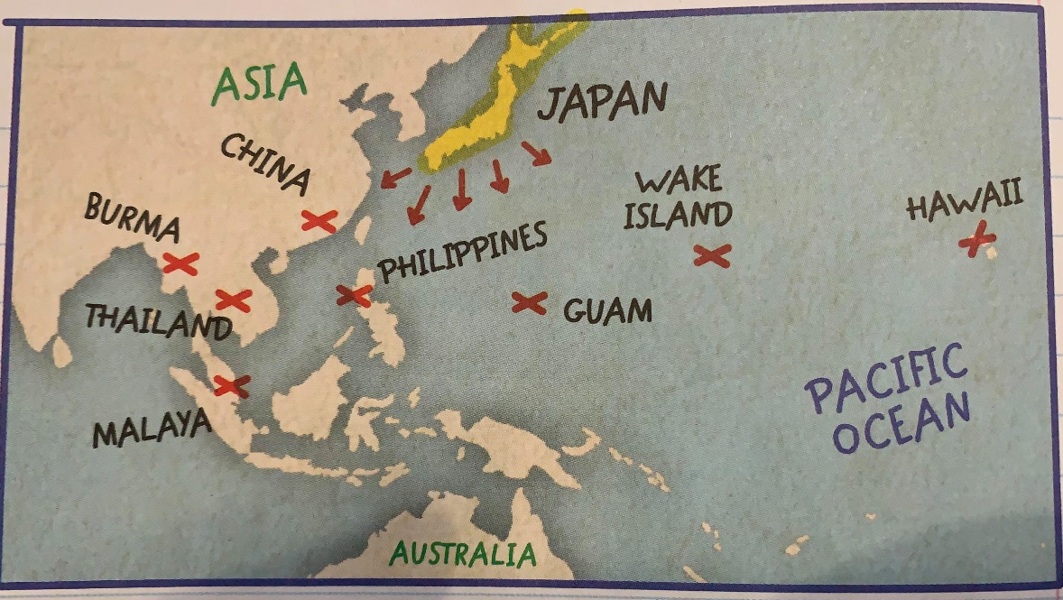
Put in command of Allied forces in the Southwestern Pacific, his first duty was conducting the defense of Australia. Meanwhile, in the Philippines, Bataan fell in April, and the 70,000 American and Filipino soldiers captured there were forced to undertake a death march in which at least 7,000 perished(see video.) Then, in May, Corregidor surrendered, and 15,000 more Americans and Filipinos were captured. The Philippines–MacArthur’s adopted home–was now lost to the Japanese.
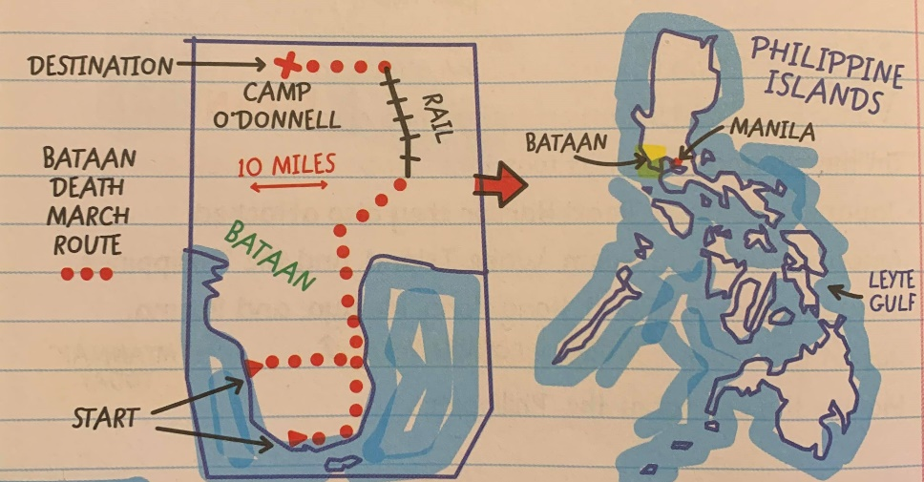
After the U.S. victory at the Battle of Midway in June 1942, most Allied resources in the Pacific went to U.S. Admiral Chester Nimitz, who as commander of the Pacific Fleet planned a more direct route to Japan than via the Philippines. By September 1944, MacArthur was poised to launch an invasion of the Philippines, but he needed the support of Nimitz’s Pacific Fleet. After a period of indecision about whether to invade the Philippines or Formosa, the Joint Chiefs put their support behind MacArthur’s plan, which could be carried out sooner than a Formosa invasion.
On October 20, 1944, a few hours after his troops landed, MacArthur waded ashore onto the Philippine island of Leyte (see map.) That day, he made a radio broadcast in which he declared, “People of the Philippines, I have returned!” In January 1945, his forces invaded the main Philippine island of Luzon. In February, Japanese forces at Bataan were cut off, and Corregidor was captured. Manila, the Philippine capital, fell in March, and in June MacArthur announced his offensive operations on Luzon to be at an end; although scattered Japanese resistance continued until the end of the war in August. Only one-third of the men MacArthur left behind on March 11, 1942, survived to see his return. “I’m a little late,” he told them, “but we finally came.”
- MacArthur and Bataan Questions Below –
1) Where are the Philippine Islands located in relation to Japan?

2) Where was U.S. General Douglas Ordered to go? Why do you think President FDR would order him to leave his home?

3) What happened to the Allied troops who stayed in the Philippines when MacArthur left?

4) In the video how did Bataan survivor Lester Tenney describe the Bataan Death March?
For what reasons could American soldiers be killed during the march?
How many miles was the death march it and in what type of conditions?
According to Lester, how did he manage to survive, both the March itself, and time spent in the Japanese Concentration camp?

5) Why was MacArthur’s promise “I Shall return” so important to him?

6) How long did it take for MacArthur to fulfill his promise?

