Name _______________________________________ Date _____________________

The Cold War

The Sides

The West Vs. The East

(_______ and its allies) (___________ ___________ and its allies)

Their Goal: ________________________ Their Goal: ______________________

Causes

From allies to enemies, fought common enemies during the war.

Ultimately the U.S. and the Soviet Union had competing _________________, __________________, and ____________________ systems.

Western nations want to spread _______________________ and capitalism.

Soviet leaders wanted to spread _____________________________.

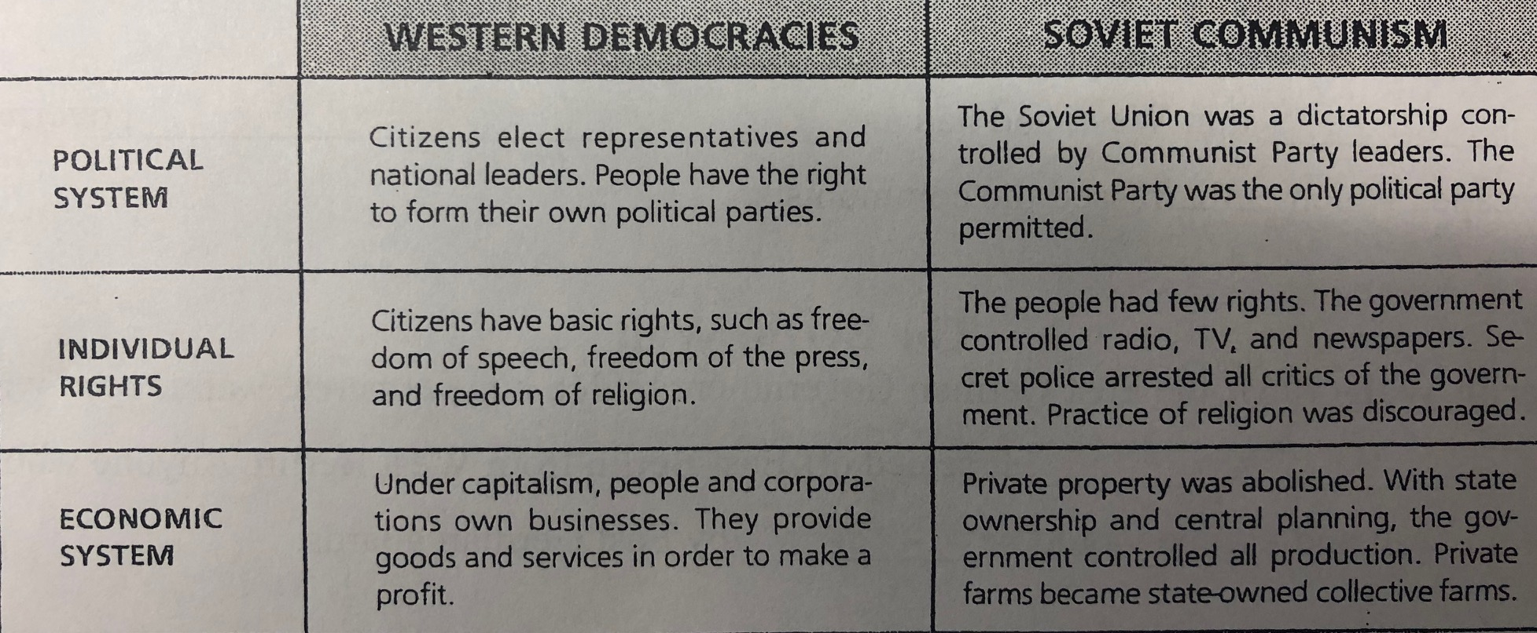

Europe After WWII

The "_______________ - ____________________” - Winston Churchill (Britain) warned against Soviet expansion into eastern Europe. The "Iron Curtain" cut off Soviet run Eastern Europe from the Democratic governments of the West.

The U.S. tries to prevent Communism from spreading

_____________________________________- President Harry Truman's policy to prevent the spread of Soviet influence beyond where it already existed.

____________________________________ - Program to encourage nations to resist communist expansionism.

_________________________________________________ - Secretary of State George Marshall, feared that the millions left homeless and hungry in Europe after WWII, would encourage _______________________________ revolutions.

June 1947 the Marshall Plan was approved by Congress providing ________________ in aid to Western European Countries to help them rebuild their economies.

Crisis in Berlin

France, Great Britain, the U.S. and the Soviet Union controlled the Capital of Germany, _____________________, after WWII. Stalin didn't want to give up his hold on Berlin, so he ____________________ his part of the city.

The Berlin Airlift

President __________________ ordered American planes to drop supplies into Western Berlin (food, fuel, etc..) This lasted almost a year. Stalin eventually lifted the blockade. Germany would later be divided.

Germany is Divided

The U.S. Britain and France merged their zones into _____________ _______________.

This became a prosperous nation with US aid.

The Soviet zone became __________________ ______________________.

It was poorer than the West, and had an undemocratic government, many escaped which embarrassed the communists.

The Berlin Wall

The Berlin Wall- built in ____________, the East German Government built a huge concrete wall topped with barbed wire. It sealed off East Berlin from West Berlin. Anyone who tried to scale the wall and escape would be shot by East German guards.

New Alliances and a Peace Keeping Organization

1948, NATO (North Atlantic Treaty Organization) - Key goal was to defend __________________ Europe against any Soviet threat. 10 nations w/________ and __________________

Warsaw Pact – Soviet Union creates this in response, Czechoslovakia, Hungary, Romania, East Germany, Poland, Bulgaria and Albania.

United Nations

June 1945, 50 nations join this peacekeeping organization, based in New York.

Made up of a:

Security Council – responsible for deterring aggression.

General Assembly – every country 1 vote.

Economic and Social Council – promotes economic and social development, world health and education.

Other Events

-Sept. 1949 - US learns Soviet Union has successfully tested an ____________________.

-Chinese Civil War:

Democrats – Led by Chiang Kai-Shek.

Vs.

Communists – Led by Mao Zedong

1949 - ____________________ - win control of China, set up the People's Republic of China.

